1. 
2. Graphical user interface

   Description automatically generated
3. Graphical user interface, application

   Description automatically generated
4. Text, application, chat or text message

   Description automatically generated
5. When we include tomcat as part of our app then the tomcat server will become “Embedded Server”.
6. Diagram

   Description automatically generated
7. Let’ see where Tomcat Embedded Server comes from.  
     
   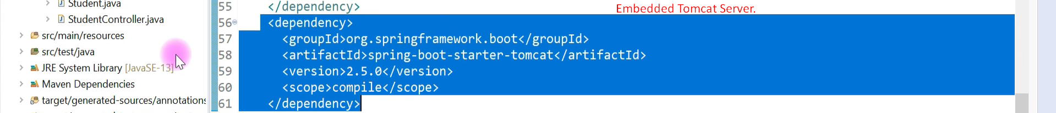  
   
8. How to change default Embedded Server Tomcat?  
   Graphical user interface, text, application, email

   Description automatically generated  
     
     
   Adding Undertow Embedded Server  
   Graphical user interface, text

   Description automatically generated  
   